Afring News | 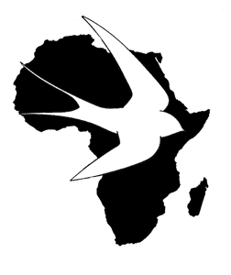

An electronic journal published by SAFRING, Animal Demography Unit at the University of Cape Town
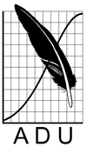

Afring News online accepts papers containing ringing information about birds. This includes interesting ringing trips, interesting captures, faunistic observations relating to ringing, and analyses of ringing data. It will also consider for publication a variety of other interesting or relevant ornithological material: reports of projects and conferences, and any other interesting or relevant material.

Editor: H. Dieter Oschadleus

[Title of paper]

[Author/s]

Recommended citation format:
(To be completed by editor)

URL: (to be completed by editor)

Published online: (date to be completed by editor)

-ISSN -

[Title of paper]

[Author/s – indicate affiliation of author with superscript numerical refering to list below]

[Insert current affiliation of each author marked clearly with numerical superscript preceding the affiliation and email address of corresponding author]

[Sample text Sample text – Please refer to the "Guidelines to authors" available on the website http://oo.adu.org.za]

Acknowledgements
[Insert acknowledgements here – if applicable.]

References
[Insert references here – if applicable. Eg

Harrison JA, Allan DG, Underhill LG, Herremans M, Tree AJ,
Parker V, Brown CJ (eds) 1997. The Atlas of Southern African
Birds, Vol 1. Non-passerines. BirdLife South Africa, Johannesburg.

Hockey PAR, Midgley GF 2009. Avian range changes and climate
change: a cautionary tale from the Cape peninsula. Ostrich 80: 29-
34.

Piersma T 1996. Family Charadriidae (Plovers). In: del Hoyo J, Elliot
A and Sargatal J (eds). Handbook of the Birds of the World Vol 3.
Hoatzin to Auks. Lynx Edicions, Barcelona: 384-443.
]

